# Pima Indian data set.

# Classification comparison between models.

Exercise 6: Neural network

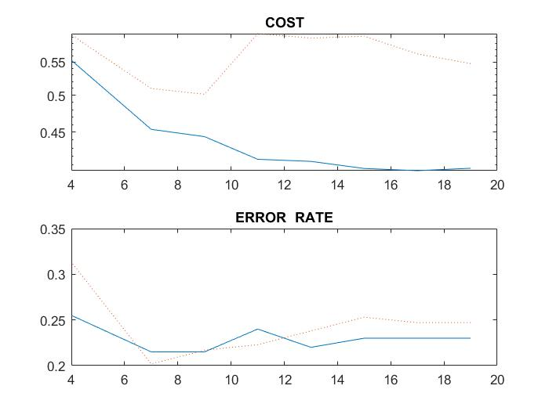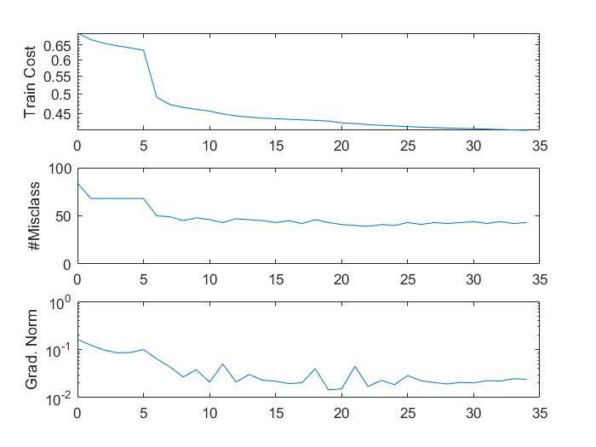

Exercise 8: Probabilities density functions

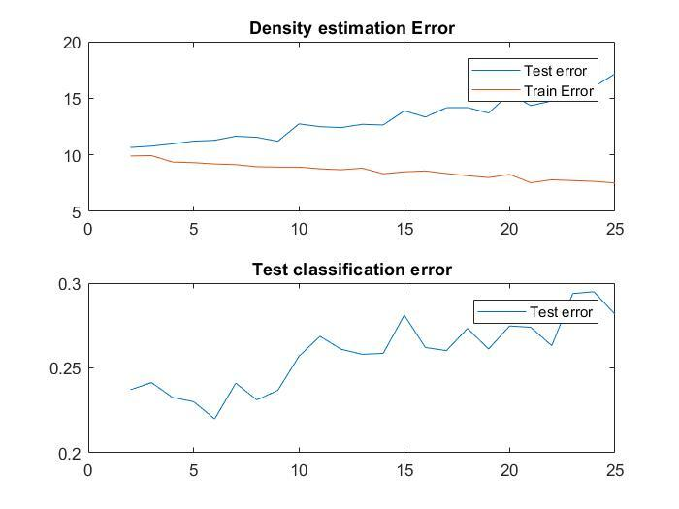

Exercise 9: KNN

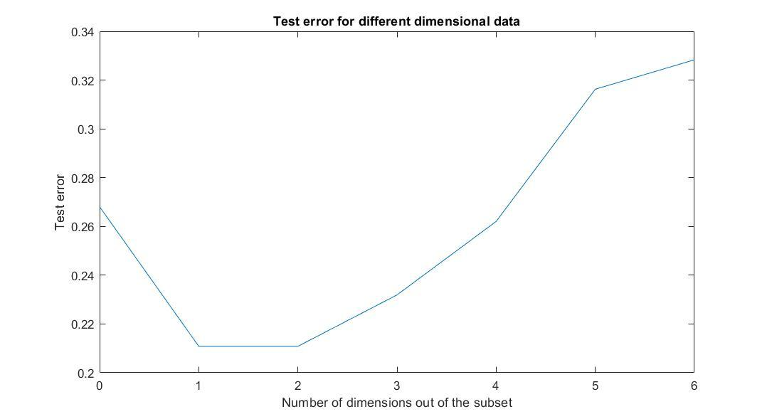

Exercise 10: SVM

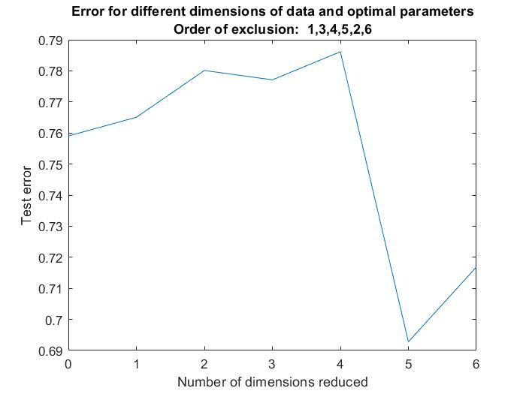(Test accuracy, not test error)